**Q1. Madhav and Mira work in a Private Bank. Both were selected through campus**

**recruitment. They are of same age and have joined together therefore both of them handle the same clients. Madhav does not agree on the products which Mira pitches to the clients and vice versa. This has created rifts and conflicts between them, at times even in front of the clients. Ramesh is their reporting authority and is thinking of ways to intervene and resolve their conflict. Discuss the various approaches that can be used for resolving conflict between Madhav and Mira.**

**Ans.**

Conflict resolution is a daily occurrence at work that can either propel or disrupt the momentum for a leader, a team or the entire organization. The workplace can become a toxic environment when leaders allow conflict to fester rather than confront it head-on.

To handle the conflict between Madhav and Mira, Ramesh should follow the listed practices:

1. Let them come-up with their stories: People are deeply upset about something, they need to get their story out. This is a basic principle of mediation and one that’s important to remember.
2. Bring a reality check to the table: Often in a conflict, the parties are so focused on minutiae that they lose sight of the big picture and its implications. As the mediator, Ramesh need to bring people back to reality by wrenching their attention away from the grain of sand and having them focus on the whole beach.
3. Identify the root cause: Once the structural root of the conflict is identified, it can be easily resolved by rational evaluation. In the case, the pitch delivered by madhav and meera will be reevaluated with organisational benefit point of view and suitable conclusions can be drawn by ramesh.

**Q2. Patanjali is the new found love of people who believe more in ayurvedic**

**and organic products. Based on the data available in the open sources do an internal environmental and organisational analysis. (You can take the data from the open sources but the analysis is to be done in your own words).**

**Ans.**

Internal Environment:

PATANJALI AYURVED LIMITED, a Company registered under the Companies Act, 1956. Presently, the Board of Directors of the Company is managed by Sri Acharya Balkrishnaji as its Managing Director along with Swami Muktanandji and Sri Ajay Kumar Arya, as Directors of the Company.

Patanjali aims at bringing forward the myriad benefits of ayurvedic herbal products to the consumer across the globe.

The mission at Patanjali is to make use of the modern technologies and the art of Ayurveda together and produce products that truly represent the “importance of life” which is what Ayurveda stands for.

Assets:

1. Already 12 successful units running including units for Packaging material and Containers e.g. flour mill, candy plant, herbal cosmetic and detergent plants, digestives unit, juice plant etc.
2. Co-packing facility-Tetra Pak and Volpak
3. Multi-fruit juice processing line
4. Nutraceutical Processing Line
5. Sale Outlets: Patanjali brand with national and international reach, more than 85,000 retail outlets-accessible to Patanjali products.

Human Resource:

1. Currently PAL employs more than 6000 labourers in its processing activities.
2. More than 400 Sales Staff.
3. PAL has more than 300 technically qualified employees.
4. PAL has provided more than 2.00 Lac indirect employment.

Organisational Structure:

PAL has a three-tier distribution system consisting of clinics, wellness centres, and non-medicine outlets to retail 800 products. The company also runs an e commerce portal that sells a wide range of products from hair cleansers to “hing peda.”

It has distribution agreements with Reliance and the Future Group and a product development arrangement with the Defence Research Development Organisation (DRDO) for food and health supplements. PAL even has an HR policy that aims at hiring executives from rivals.

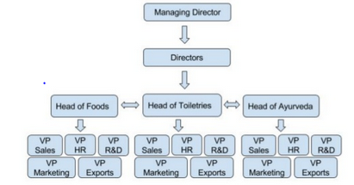

Finance:  
The company has been taking short term loans to meet their working capital. In the past, public sector banks like Punjab National Bank and SBI have lent credit to the company. But, the recent updates states that company is planning to raise Rs 1,000 crore in project loans as its current capacity is bursting at the seams.

The company doesn’t have much outside funding scenarios and has a flagship of trust and followers.

Organisational Analysis:

Patanjali is getting into hearts of Indian people as by his ayurvedic products. The company is scaling on the basis of Indian culture and rituals with use of natural ingredients in their products. Giving stiff competition to other foreign market holders, patanjali is serving people with mix art of ayurveda products and yoga. The foreign vendors are facing a stiff competition with the advent of natural products which implies imitability and rareness.

**Q3. Case Study : Foodie Hub**

**Foodie Hub is the famous food chain which has its outlet in all the metro cities. It has been running successfully since many years. The employee strength is around 700 in total across all the outlets. There management is a lot like that of a**

**Bureaucratic organisation where lots of hierarchical levels are followed. Even for a small requisition you have to be dependent on your superiors. There is no delegation of authority and the employees are not even empowered to take any decision at their own level. Employees have started leaving the organisation and the absenteeism is also very high. The management hires Atul as a consultant to help them solve this concern.**

**Case Questions**

**a) what would be the ideal organizational design for a company like Foodie Hub**

**Ans.**

As the company operates in multiple cities, the best course of action is to use decentralized organisational structure where a branch manager is responsible to carry out the daily operations at a particular branch. Here, The branch manager is responsible for reporting daily business activities and communication of various business operational inefficiency and issues. This decentralized structure of an organisation will help the eradicating the slow response time in operational activities and will eventually greece up the mechanics of business. Some degree of participative nature can be inherited in business activities according to the intensity of situations arising at a regular pace. Employees of the organisation can be involved in few decision making process to make them feel as a valuable part of organisation and to boost up their morale value.

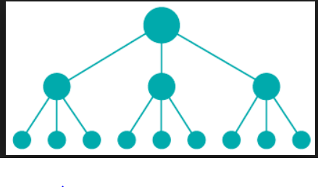

**b) What steps should Atul take to restructure the organisation?**

**Ans.**

Restructuring an organisation is a complex process where each and every entity of business operation is taken into account. The shift of structure from centralized to decentralized organisational structure involves a high degree of responsibility assigned to an employee which gave rise to multiple risk factors. Appointing a manager with high degree of responsibility is a crucial step to be undertaken in decentralized organisational structure.

Steps to restructure the organisation are:

1. Define clear goals and objectives in context to which Roles and Responsibilities of the decentralized position are defined.
2. Define the organisational structure considering all the requirements of business operations.
3. Clearly define the management information system, to decide the chain of command to be followed in an organisation.